MACH4METAL

metalworking machinery
Transito 21
6909 DA BABBERICH Netherlands
Tel. +31 (0)316-247123
Fax: +31 (0)316-247956
info@mach4metal.com
www.mach4metal.com

Bank No : 66.52.13.883
IBAN : NL33 INGB 0665 2138 83
BIC : INGBNL2A

BAYKAL Pressbrake 1200 x 35 T
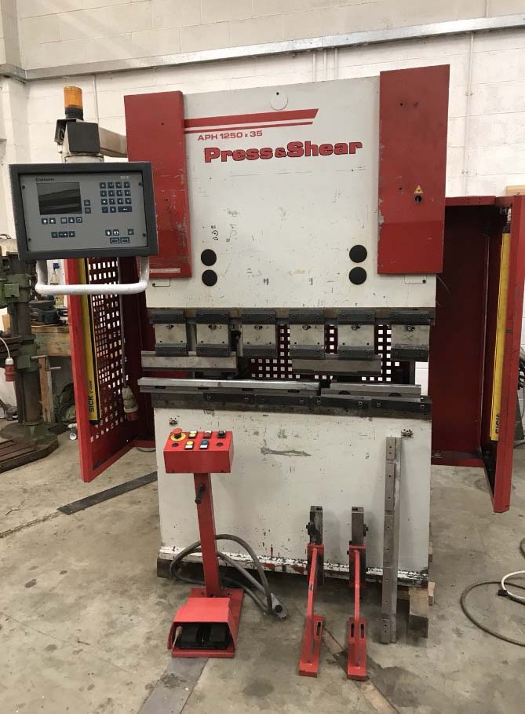

- Make : BAYKAL
- Type : APH
- No : 701 304 5289
- Age : 2004

- Max. bending length: 1.200
- Between column : 1.070
- Max. force : 35

- Beam stroke : 60 mm
- Depth of throat : 150mm

- Approach speed : 100 mm/min
- Bending speed : 10 mm/min
- Return speed : 70 mm/min

- DELEM M-51 Electric Backgauge

- Dimensions
- Length : 1.250
- Width : 1.270
- Height : 2.150
- Weight : 2.200
- Power : 4 kW
- Oil capacity : 80 L

Please Note: The above information has been obtained to the best of our ability and belief from, and from the manufacturers where possible. It is given in good faith, but its accuracy can not be guaranteed. Accordingly, it will not form a representation or constitute contractual terms. We advise you to check any vital details!

